Technology is giving us clues into how people read online resumes—how their eyes travel over the page, where they pause, what they move to next. Dr. Jakob Nielsen, a pioneer in the field of usability, conducted an eye-tracking study on the reading habits of web users. The research study displayed that participants exhibited an F-shaped pattern when scanning web content.
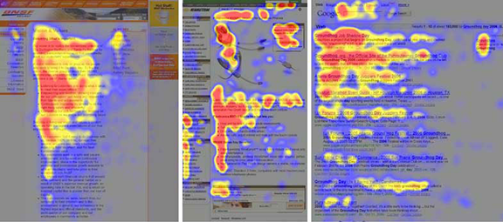
With this “F factor” in mind, when you are composing your resume, LinkedIn profile, cover letters, or other career-com documents, think about how you can position key information and impressive accomplishments in these areas. Doing so will increase the likelihood of readability and comprehension for recruiters and hiring managers.
Here are six secrets to leverage the “F factor” in resumes:

1. Use Keyword In Headings And Subheadings
Choose keywords for headings and subheadings when possible. For example, instead of “Professional Experience” as a category heading on your resume, consider “Sales Management Experience” or “Customer Service Experience” or other appropriate title. As recruiters scan the resume headings, they’ll get an extra dose of the keywords they’re looking for.

2. Position Impact Statements Near The Company Name
Since readers look for company names and dates as part of their first impression, consider adding a key impact statement or accomplishment between the company name (on left side of resume) and the date (on right side of resume), as this example with yellow highlighting shows:
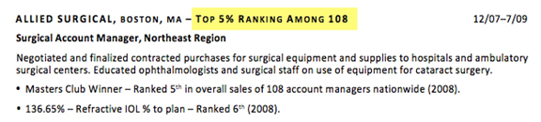

3. Lead With Info-Carrying Information
Front-load paragraphs and bullet points with info-carrying words, accomplishments, and/or numbers. For example, instead of saying “Developed strategy to boost untapped VA contract from $250K to $2.5M”, lead with “10-fold increase: Built VA contract from $250K to $2.5M.”

4. Use Graphics To Convey Key Information
Consider adding a graph or chart to convey important information. A picture IS worth a thousand words!

5. Keep Key Info Above The Fold
Keep the meatiest information up high on the page. Even though many resumes are read on a computer screen, the information near the first third to half of the page is still the most important real estate on the page/screen.
6. Center Important Points Near “F” Barsonsider centering key information in a text-box, as the example below shows.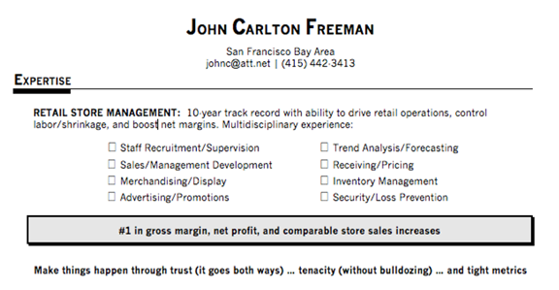
Review your resume today and consider potential tweaks to increase its readability. Getting the “F Factor” into your resume may earn you an “A” in your job search!

Careers author, speaker, and trainer, Susan Britton Whitcomb is a leading authority and media resource on career coach certification via www.TheAcademies.com.

How Ty Positive During A Frustrating Job Search

