Assuring Excellence
At BarryStaff, we aren’t eager to repeat mistakes.
Employees with a history of not showing up to work or for not following the rules are marked “NER” in our system. That stands for “Not Eligible for Rehire.” After more than 30 years in the business, we know who we can count on. And who we can’t.

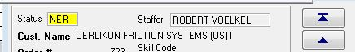

We also keep detailed notes on all employees. This information is easily accessible to our staffers so they can make good decisions for our clients.

